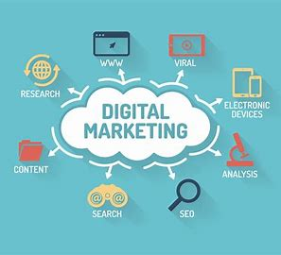

Digital marketing refers to advertising delivered through digital channels such as search engines, websites, social media, email, and mobile apps. Using these online media channels, digital marketing is the method by which companies endorse goods, services, and brands.
Digital marketing is the component of marketing that utilizes internet and online based digital technologies such as desktop computers, mobile phones and other digital media and platforms to promote products and services.

METHODS
• Search Engine Optimisation (SEO)
• Search Engine Marketing (SEM)
• Content Marketing
• Social Media Marketing
• Mobile Marketing
• E Mail Marketing
• Affiliate Marketing
• Web Analytics

SEO – SEARCH ENGINE OPTIMISATION
Search engine optimization (SEO) is the practice of increasing the quantity and quality of traffic to your website through organic search engine results.

(SEM) – PPC, ADWORDS • Search Engine Marketing (SEM) is the process of gaining website traffic by purchasing paid ads on search engines.

Difference between SEO and SEM • SEM is usually more expensive than SEO. • SEM can have an instant impact and drive traffic immediately. • SEO usually takes several months to get results.

SOCIAL MEDIA MARKETING Social Media Marketing refers to the process of gaining traffic or attention through social media sites. • • • Facebook Marketing Twitter Marketing Linkedin Marketing Video Marketing (Youtube) Instagram, Pinterest, Tumblr, Quora, Google Plus.

WEB ANALYTICS Web analytics is the measurement, collection, analysis and reporting of web data for purposes of understanding and optimizing web usage. • Locations • Traffic sources • Audience • Demographics • Conversion tracking • Bounce rate • Page views • Device Types

• Affiliate Marketing - Affiliate marketing is the process of earning a commission by promoting other people’s (or company’s) products / Services. • Content marketing is the process of creating high-quality, valuable content to attract, inform, and engage an audience, while also promoting your brand.
• E Mail Marketing is the use of E Mail to promote products/services by developing relations with potential customers and turning them into loyal customers.
• E Commerce Marketing - Ecommerce marketing is the process of driving sales by raising awareness about an online store's brand product offerings.
• Online Reputation Management – ORM is the process of improving or restoring the reputation of your brand.
• Blogging and Adsense – Writing an online blog, building traffic and earning money by displaying advertisements.

